**Test Case 4 – Simple Atrium Example with Continuous Hole**

*Test Description* : A 7-zone model with a simplified, generic typical commercial building floor plan on the first floor. A large open area perhaps similar to a dining area or large open common space is on the second floor. A large 4-sided pyramidal skylight is provided for daylight in this common space. To provide some daylight on the first floor, a hole has been cut in the floor slab separating the first and second floor.

This test is designed to ensure that second level space boundary requirements are fulfilled, and that holes in floor slabs are properly represented as an Opening with openingType = “Air”. It is possible that the holes could also be modeled as a Surface with surfaceType=”Air”, but this second option is not allowed for this test at this time due to limitations of the validator to search for both and have both be equally valid. This limitation of the validator is intended to be removed in the future.

*Space Names:* This is important because the gbXML validator requires the strings in the test file match the standard file. The name check is case sensitive. Ensure that the id attribute of the Space elements in the gbXML test file match.

|  |  |  |
| --- | --- | --- |
| Standard File Space Name | Test File Space Name | Verified |
| Level_2_Open_Space |  |  |
| Level_1_W_Perimeter |  |  |
| Level_1_N_Perimeter |  |  |
| Level_1_E_Perimeter |  |  |
| Level_1_S_Perimeter |  |  |
| Level_1_Interior |  |  |
| Level_3_Roof_Void |  |  |

*Special Considerations:*

1. this test is designed to check if holes are represented in the model, which may be important for both daylight and natural ventilation examples. The skylights have been modeled as openingType=”OperableSkylight” to highlight this fact.
   1. your uploaded file must also have openingType=”OperableSkylight” else the validator will fail the detailed opening tests
2. The skylight (called Level_3_Roof_Void) has a small curb, which is not excluded from gbXML currently. It is expected that the curb will appear in the model as a series of short (squat..i.e.- small Z-height) exterior walls, until curbs are more explicitly defined as a skylight feature for gbXML objects.

*Complexity of the BIM Model:*

1. Simple planar surfaces orthogonal to the project Cartesian reference frame.
2. Exterior walls of thickness =, interior walls of thickness = used in the project,
3. Simplified walls with no visible layers.
4. Simple details at interfaces of surfaces.

*Description of Test:*

The building is a two story building with a large pyramid skylight embedded in the roof. The perimeter zones are all evenly spaced. It is an 80’ x 20’ building with no other windows or shading devices.



***Level1***

***S Perimeter***

***Level1***

***N Perimeter***

***Level1***

***E Perimeter***

***Level1***

***Interior***

***Level1***

***W Perimeter***

Figure 1: Level 1 Floor Plan schematic.

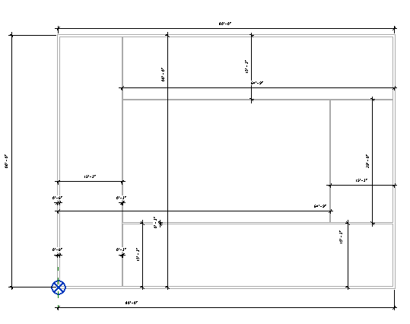

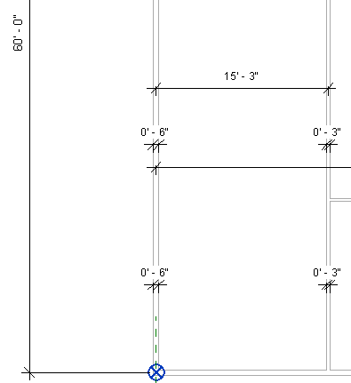

***Level1***

***W Perimeter***

Figure 2: Level 1 W Perimeter Dimensions and wall thicknesses. For the zone dimensions, only the centerline to centerline is shown because this is all that is needed to pass the validator at this time.



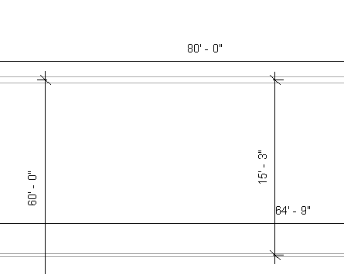

***Level1***

***N Perimeter***

Figure 3: Level 1 N Perimeter Dimensions. Wall thicknesses are the same as Figure 2 for interior and exterior walls. For the zone dimensions, only the centerline to centerline is shown because this is all that is needed to pass the validator at this time.



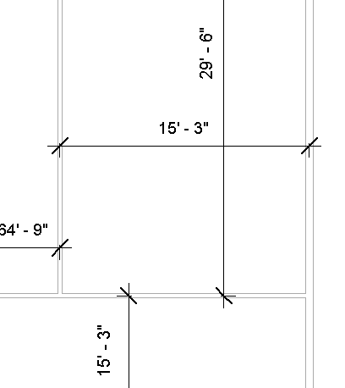

***Level1***

***E Perimeter***

Figure 4: Level 1 E Perimeter Dimensions. Wall thicknesses are the same as Figure 2 for interior and exterior walls. For the zone dimensions, only the centerline to centerline is shown because this is all that is needed to pass the validator at this time.



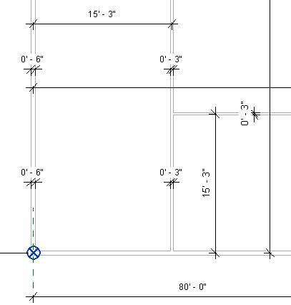

***Level1***

***S Perimeter***

Figure 5: Level 1 S Perimeter Dimensions. Wall thicknesses are the same as Figure 2 for interior and exterior walls. For the zone dimensions, only the centerline to centerline is shown because this is all that is needed to pass the validator at this time.



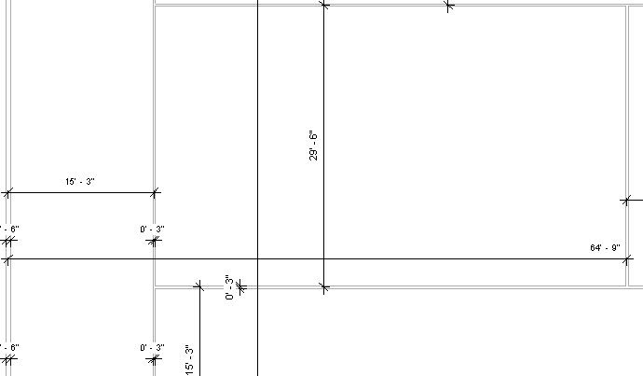

***Level1 S***

***Perimeter***

***Level1 W***

***Perimeter***

***Level1***

***Interior***

Figure 6: Level 1 Interior Dimensions. Wall thicknesses are the same as Figure 2 for interior and exterior walls. For the zone dimensions, only the centerline to centerline is shown because this is all that is needed to pass the validator at this time.

80’

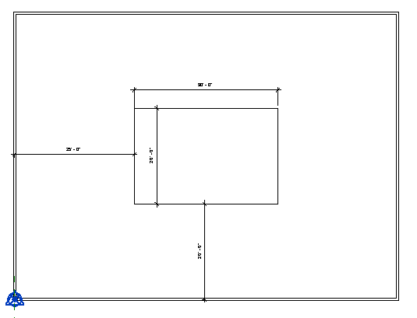

60’

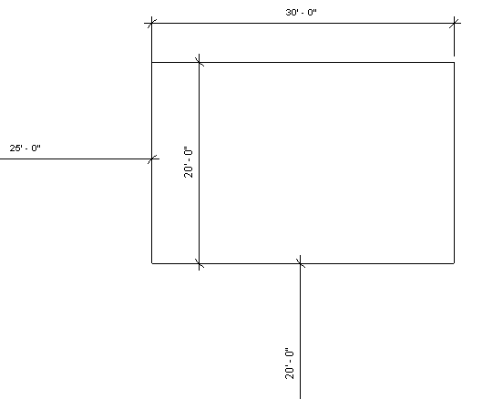

Figure 7: Level 2 Open Space Schematic Floor Plan. This schematic highlights the dimensions of the opening in the floor and its relationship to the origin.

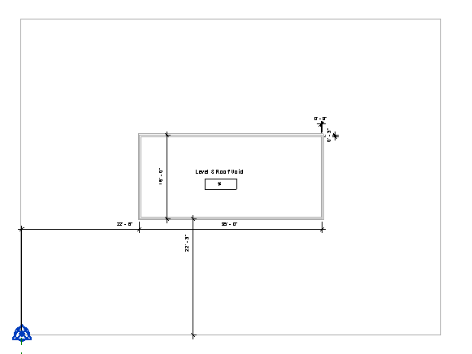

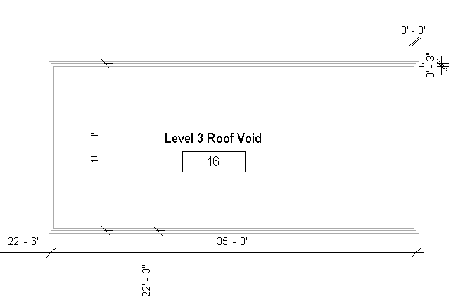

Figure 8: Level 3 Floor Plan, showing the dimensions of the roof void (skylight base) in plan view. The wall thickness shown (3”) is the thickness of the skylight curb that will be referenced as a Surface of surfaceType = “ExteriorWall” in the gbXML file.

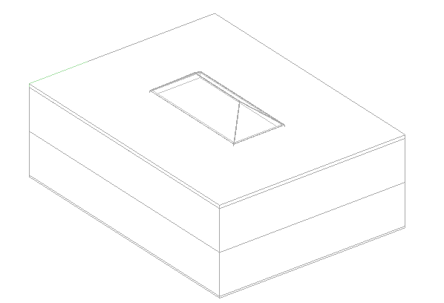

Figure 9: 3D Axonometric View.

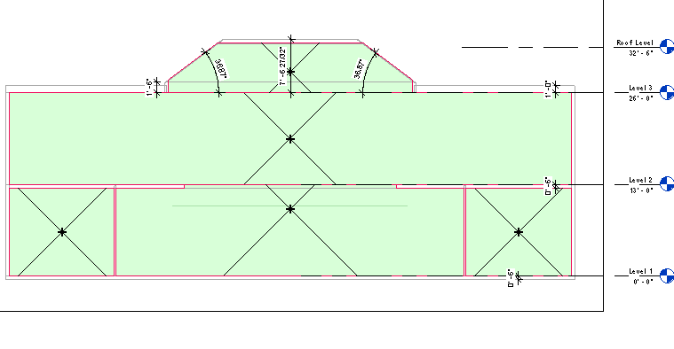

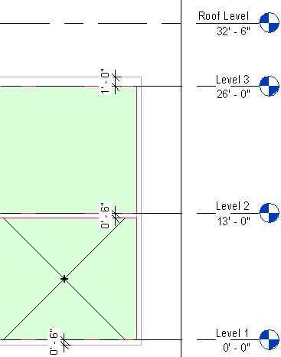Figure 11: Schematic Section Cut.

Figure 10: Floor to floor heights and slab thickness.

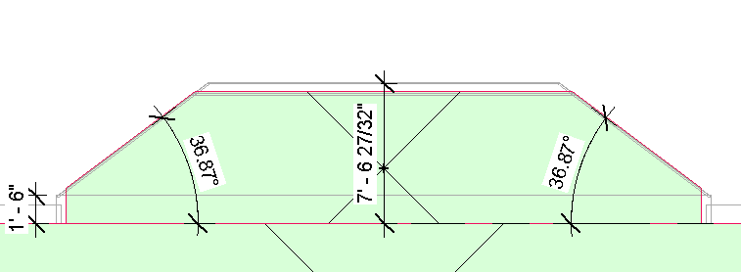

Figure 12: Angles of pyramidal skylight and height of roof curb.

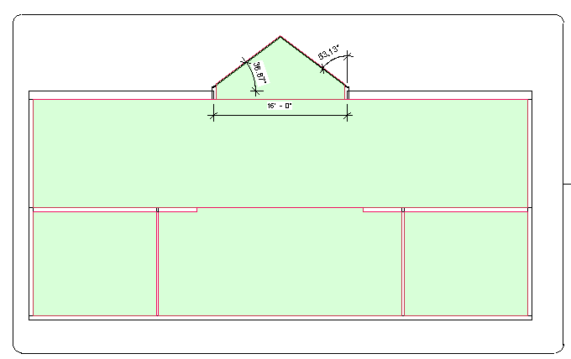

Figure 13: Building Section Looking East

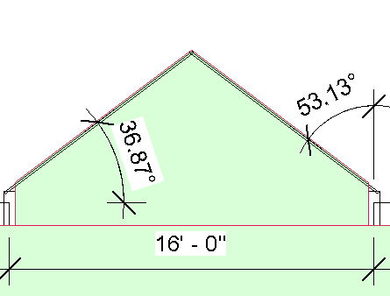

Figure 14: Detailed section cut of skylight

|  |  |  |  |
| --- | --- | --- | --- |
| Wall Description | Wall Thickness | Wall Type | Comments |
| Exterior Wall | 6” | Simple |  |
| Interior Wal | 3” | Simple |  |
| - | - |  |  |

Table 1: Dimensions and descriptions of wall elements in Test Case 1.